# ML homework 2: question 11

The scatter plot of $(E_{out}(g), E_{in}(g))$ is as the figure below:

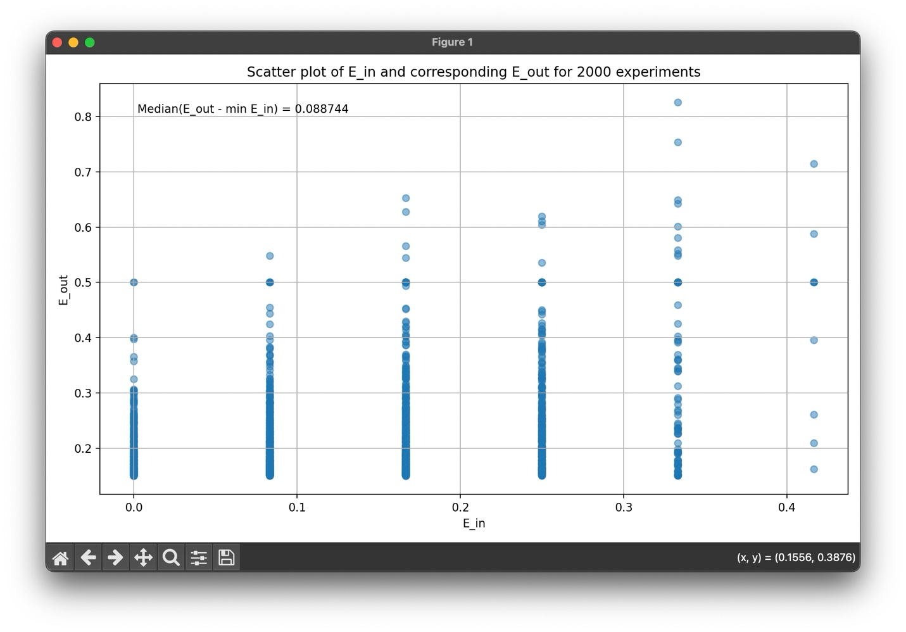

The median of the difference $E_{out}(g) - E_{in}(g)$ is about 0.088744.

## Code snapshot:

In the first part of my code, it’s about the basic setups, like generating the x values and the y values with noise, combine them into tuples to present like data points, and sort the data points by the x value as required:

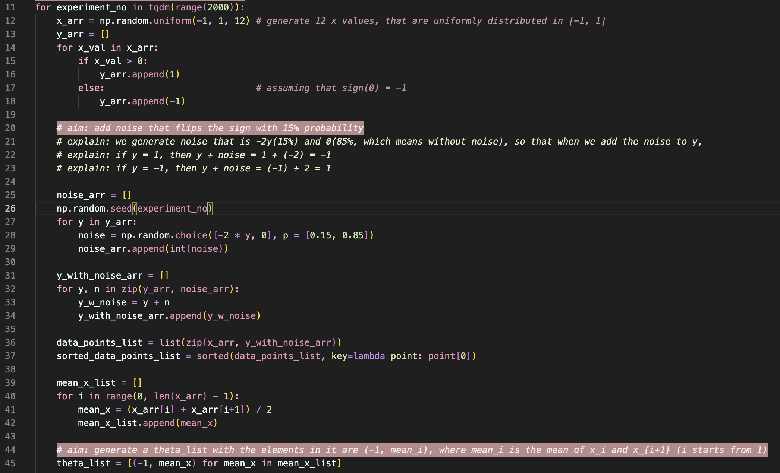

The next part is to calculate the in sample error of all possible combinations of s and theta, then find the minimum in sample error, and record its corresponding s and theta, if multiple pairs of s and theta can result in the minimum, then choose the optimal pair as the one with the smallest product:

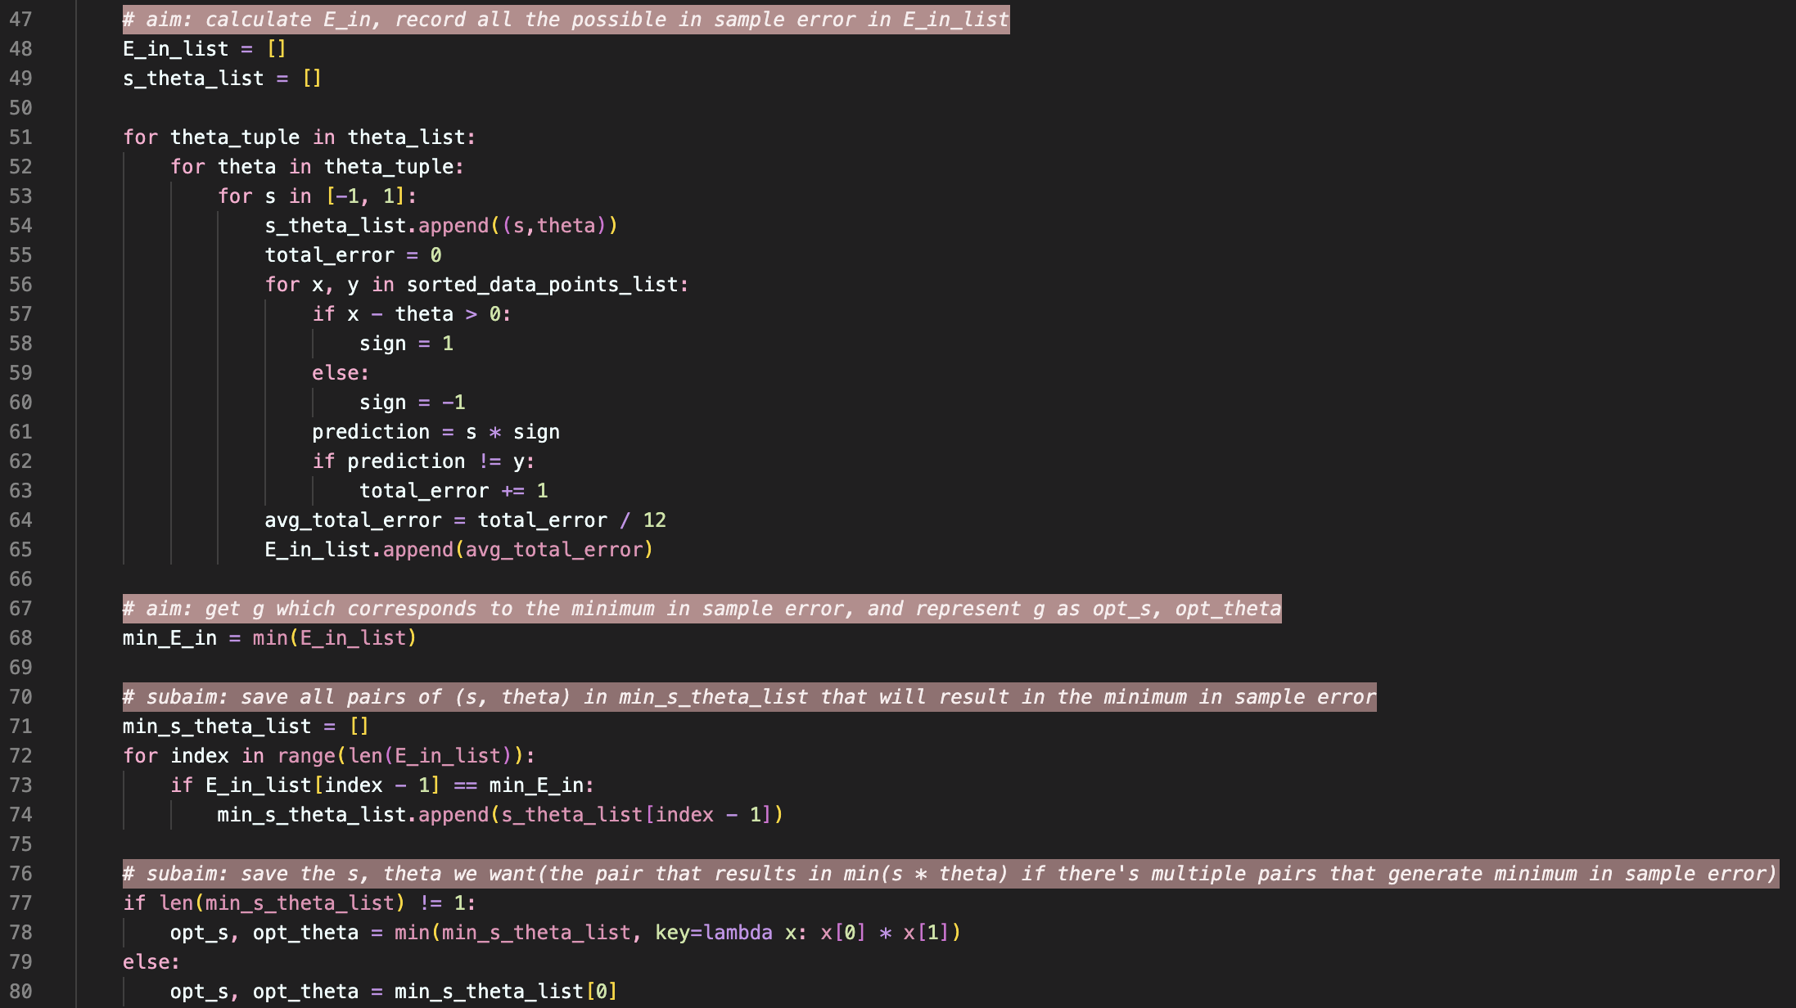

After this, calculating the corresponding out of sample error is quite simple, we just plug in the optimal s and theta values:

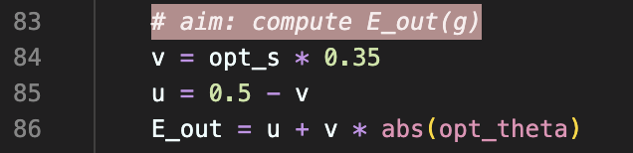

The last part is recording the results of each experiment and plot the scatter plot. This part is quite simple so I won’t put the code here, if other part of the code is needed, please let me know ☺